Fine Arraye : Clothing of the 13th and 14th Centuries
Jennifer Geard (Alys de Wilton) University, July 2001

Overview and Scope
- Clothing of the middle Middle Ages retained many features over a period of some centuries.
- We will be examining styles of clothing where the main garment was a kirtle, often worn with some form of surcote.
- The style was international with regional “dialects.” Although my focus is England and France in the early 14th century, examples may be found throughout Europe.

Sources: How do we know what the clothing was like?
- Surviving garments
- Representations in artworks
- Written descriptions (from poetry to household accounts)

Changes Over Time
- The trend over the two centuries under study was from long flowing garments to shorter fitted ones, and then away again to another type of loose garment. There were changes in the cut of the shoulder, the insertion of gores (especially centre gores), and the use of fastenings.
- Different styles co-existed. Garments and garment styles survived in use long after they were the height of fashion. A sleeveless surcoat style which was all the rage in the mid-1200s would still have been worn at home and by the less wealthy a century later.

Principles:

1. Efficiency
- Dorothy Burnham’s Cut My Cote approach: cutting efficiently from (often narrow) loomwidths.
- Geometric patterns made of rectangles, triangles and trapeziums.

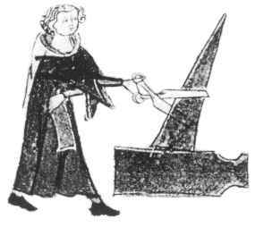
B.M. MS Harl. 6563, 14c.

2. Seaming
- Where there is a slit, look for a seam.
- Side gores had been used in the previous century (C12th).
- Centre gussets become common in the 13th century.

3. Armscythe
- Shaping of the armscythe and shoulder crown went from slight to marked over this time.
- This is the main factor to watch in the transition from a geometric cut to the tailored grande assiette (big plate) armhole of the later jupon style.

4. Cloth
Fabric choice is important:
- The body of the cloth affects drape.
- A slight amount of give affects fit.
- Weight, warmth and wearability affect usefulness.

5. Fashion & Practicality
- There were fashions -- even fads -- in clothing. They could be indulged by the wealthy.
- Domestic wear and the clothing of workers tended to stay static.

6. Size of Wardrobe
- Most people had very few clothes.
- Change your underwear, but not your outerwear.
- Underwear gets laundered.
- Outerwear gets aired, brushed and spot-cleaned.

Garments
- Underwear: shift or shirt and breech
- Hose and footwear
- Kirtles
- Hairdressing and headgear
- Overcoats (surcotes)
- Mantles
- Accessories
- Decorative treatments

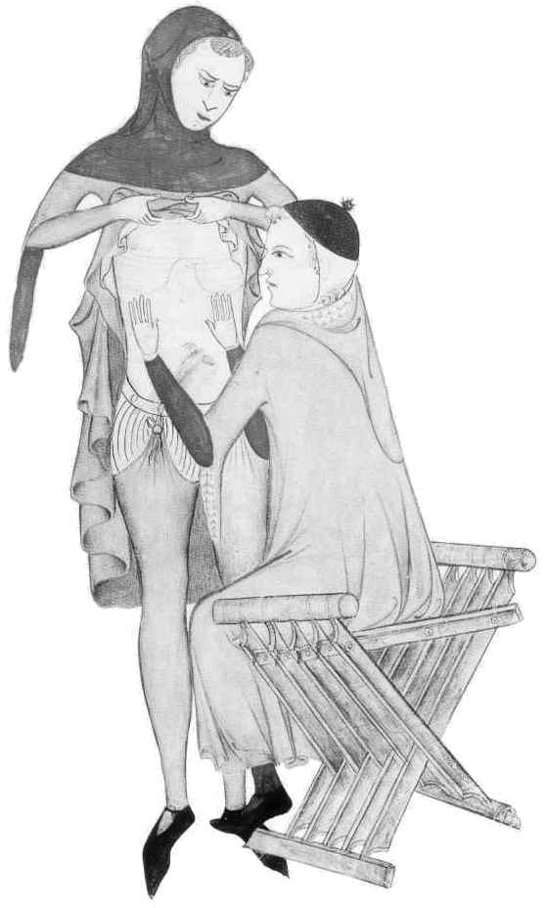

Underwear
- Usually of linen, which seldom survives.
- Shirt and breech-clout for men. Shift (long shirt) for women.

Shirts and shifts
In general, the shirt was only slightly shorter than the kirtle. However, note that the St. Louis shirt from the 13th century is perhaps calf-length, suiting the longer kirtles of the time.

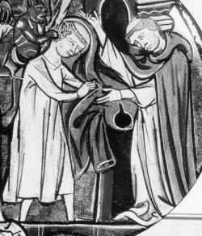

Women might wear a tight-fitting sleeveless shift, usually with shoulder straps. Seen on bath-house keepers and new mothers.

Breech-clouts
- The breech-clout or breeches tended to be longish, coming to points about knee-length. This allowed a good overlap so they’d tuck into hose.
- In the late-14th- and 15th-centuries, when hemlines and hose rose, the breech-clout shrank to the jockey brief.

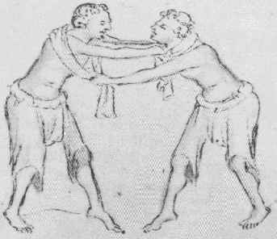

Hose
Knee-high, worn with garters which could be like miniature buckled belts or tablet woven (f and sometime m, especially under long robes).

Men’s hose grew higher as their hemlines climbed. Under the knee-length kirtle hose tended to come to a point at mid-thigh, being tied to the breech belt. Those wearing mid-thigh-length kirtles needed hose which came higher on the leg. This trend led evenatually to joined hose and the advent of the codpiece.

The Bocksten bog body wore two layers of hose. When illustrations show hose folded down for coolness the lining is often a different colour. This might indicate two layers of hose, or it might suggest a full lining (or artistic convention).

The Feet of Hose
- Footed
- Footless, often with stirrup strap
- Soled (see also Pattens)

Footwear
- Shoes, usually of leather. Goatskin was favoured, since it is fine, supple and fairly tough. Shoes could be strapped and buckled, laced or slip-on. Low– no heels–and soft.
- Low boots.
- What might be high boots or might be a type of over-hose worn by horse-riders.
- Pattens of wood (usually a light wood that can tolerate wet, such as willow or ash) or layered leather.

Kirtle
- Also called a cote, cotte, cotele or tunic. (Kirtle is an English word from cotele, which is a variant of cote.)
- Basic item of clothing, usually worn.
- Cut in rectangles and triangles.
- Often belted.

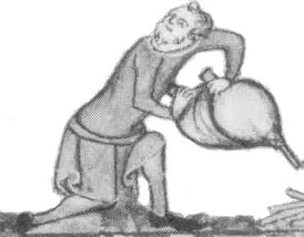

Kirtles: Length, Splits and Blousing
- Women’s kirtles between ankle-length and trailing on the floor.
- Men’s kirtles commonly knee-length.
- Ankle-length or longer for formal wear and older, high-status men.
- Fashionable men’s garments could be above knee-length in 2/2 14th century (although changes in cut and appearance mean these short fitted garments usually go by other names.)
- Men’s kirtles were commonly split at front and back from the hem to near the crotch.
- Horse-riding?
- To prevent the skirt flying up during active work, men would tuck a corner of the split into the belt.
- Kirtles could be bloused over a belt to shorten them and pad the hips and tummy.
- Women’s kirtles sometimes kilted up to ankle-length.

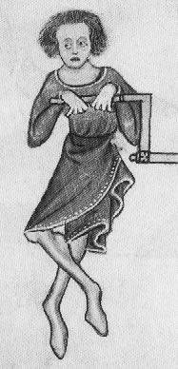

The Cotehardi?
- The garment some call the cotehardi is a tight surcoat.
- Worn over a kirtle, which often shows at the forearms and lifted hem.
- May be buttoned or spiral-laced at the centre front. Alternatively, some seem to have been laced or sewn on under the arm.
- Typically fitted on the upper arm, with a bell, tongue or tippet instead of a forearm covering. Some writers claim this is the distinguishing feature of the cotehardi.
- It’s a top layer: usually can’t integrate another layer over the sleeve tongues or tippets.
- BUT can’t always distinguish between kirtle and long-sleeved garmet which is in all other respects a cotehardi.

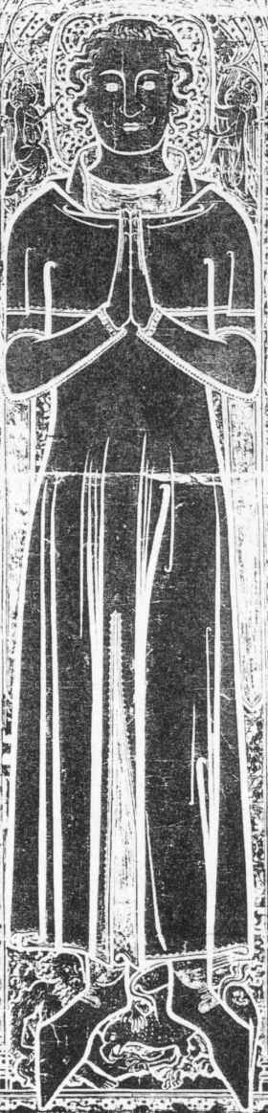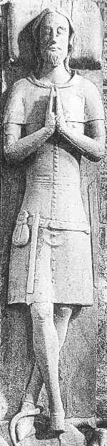
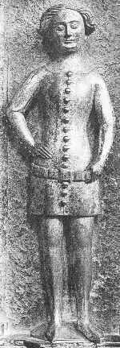

Hairdressing and Headgear

Hairdressing
- Women’s hair long. (Few exceptions: symbolism and illness.) Centre-parted, plaited in two or four braids and coiled or wrapped around the head.
- Men’s hair chin to shoulder length. Centre partings or brushed forward from the crown. Curls or wavy and flicked under at the ends with a small short fringe. Beards rare but not unknown - had fashions.

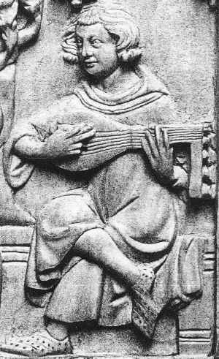

Veils and Wimples
- Veil characteristic of married women.
- Wimple draped under chin.
- Barbette.
- Combinations of veils, wimples hats and hairdressing.

Coifs
- Close-fitting cap with ties under the chin.
- Invariably white.
- Could be worn under just about any other headgear.
- Survived a long time in the clothing of lawyers and scholars.

Hoods
- Common headgear at all levels.
- Could be worn in many ways. Especially common was folding the forehead edge back to make the hood fit closely to the face.
- Men’s hoods generally closed at throat, women’s generally open.
- Front-gusset or side-gusset patterns.
- Could be worn over coifs, veils or pillbox hats. Worn under sugarloaf hats and sometimes the chapeau-a-bec.

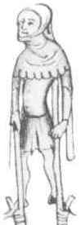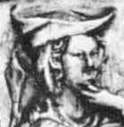

Hats
- Most types worn over a coif.
- Berets: close-fitting with stalk
- Close-fitting bowler hats
- Sugar-loaf rounded hats
- Pill-box styles
- Pilgrims’ hats and sunhats
- Chapeau a bec, worn back and front

Overcoats
Surcote - Supertunic - Overcoat all mean the same

1. Surcotes
- Common garment. Dalmatic cut.
- Larger version of a kirtle.
- Sleeves often folded back.
- Often slit at sides.
- Practical alternative to a mantle.

2. Sleeveless & Sideless Surcotes
- Typical garment - important to the look of the time.
- Over time the sleeve holes got bigger and the band of fabric at the front of the body got narrower.
- Shape of sleeve holes could be squared or rounded.
- Women’s sideless surcoat became fossilised as the ceremonial garment of queens and princesses long after it went out of general use (ermine-plastroned sideless surcoat to C16th).

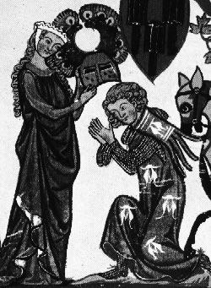

3. Garnache
- Characteristic cape-like sleeves and tongued tabs at throat.
- Worn by men.

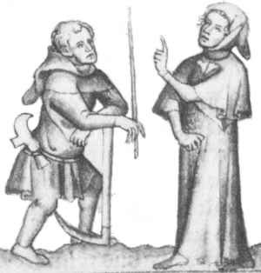

4. Gardcorps or Herigaut
- Voluminous.
- Tubular sleeves, usually long, pleated and with vertical slits for the hands.
- Worn for warmth, especially while travelling.

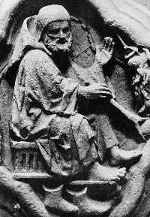

Mantles
There are two main types of mantle:
- Travelling capes, usually with hoods. These were tough, practical garments for keeping the weather out, and may be direct descendants of the Roman cucullus. They tended to be working class garments.
- “Dress” mantles which were worn as good clothes, including the floor-length ceremonial front-fastening mantle worn by noble women and the occasional noble man, and the shorter side-fastening mantles which were worn by men.

Front-fastening mantles fastened:
- With a cord which tied on one side. The fabric it contacted might be reinforced or decorated with bosses.
- With a simple strap (Last Judgement, Cathedral of Bourges). This style tended to slide backwards, and many representations show people holding the centre of the strap down to stop it strangling them (the anti-choking maneouvre.)

Side-fastening mantles might be sewn closed on the sword-arm-shoulder (as is the Bocksten mantle) or fastened with buttons (a later and wealthier style).

Dress mantles limit the movement of the arms, so people who have to work for a living would instead wear a surcoat, often sleeved, for warmth or a cape for the weather.

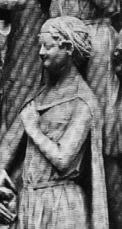

Accessories

Belts
- Buckled with hanging tongue.
- “Knightly girdle”.
- Ceinture + sword-belt.

Purses
- Gipcieres, aumonieres.
- Big pouch for hunting.

Daggers and Knives

Gloves
- Fingered gloves high-status or for hawking. (Wrist hem always pointed.)
- “Two-fingered mittens” used for field work.

Aprons
- Women’s aprons rectangular and tied at the waist.
- 14th century aprons often have a band of decoration below the waistband.
- Butchers and blacksmiths might wear protective aprons of leather.
- Male cooks wear what looks like a cloth apron (Luttrell Psalter)

Jewelry
- Fermail brooches - functional.
- Plaque belts.
- Circlets and coronals.
- Rings.

Decorative Treatments
- Dagging
- Mi-parti – parti-coloured
- Rows of dots just inside the garments’ edges are common in illustrations. Twining vine decoration sometimes noted in same place.
- Brocaded and embroidered fabrics.
- Contrasting linings.

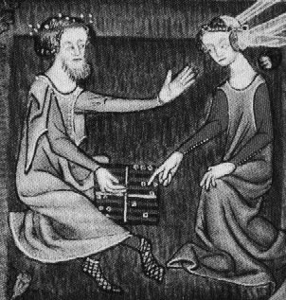

Select Bibliography

Carlson, I. Marc. Some Clothing of the Middle Ages. http://www.geocities.com/Athens/Parthenon/5923/cloth/bockhome.html

Cunnington, C. Willett, and Phillis Cunnington. Handbook of English Mediaeval Costume. Illustrations by Barbara Phillipson and Catherine Lucas. London: Faber, 1969. Rev. ed. (First published 1952.) 210 pages. Bibliography: 190-194. Index: 203-210. SBN: 571046703.

Line drawings from noted original sources. 3 leaves of coloured plates.

“The aim of this Handbook is to present in a concise form a systematic account of English Mediaeval Costume, from A.D. 800 to A.D. 1500.” (p. 6) The Cunningtons achieved their aim so well that this book remains the leading source for systematic and descriptive classification of medieval English clothing. A densely packed treasure, small enough to be easily comprehensible, yet detailed enough to list the components of dress for each century or half-century, giving the dates when alternative styles were fashionable, and mentioning when and by whom certain garments would be worn. This is not a physically impressive volume, but any who ignore it in favour of the more lavishly illustrated browsing books are missing out on a framework for understanding and a depth of explanation which is still rarely found elsewhere.

Davenport, Millia. The Book of Costume. New York: Crown, 1948. Printed in two volumes: vol. I: 1-468; vol. 2: 469-958. “Appendix of Sources”: 935-945. Index: 946-958. ISBN: none.

2778 B&W photographs of artworks and artifacts.

Hugely influential work, being an annotated collection of B&W photographs of costume resource material from art and archaeology. Just about every artwork that has become known and reproduced in later costume books is found here, along with pictures of dated items of clothing which could with some benefit be circulated again. Figures 435-446 show the parts of armour and the development of styles of various pieces of fighting gear over the centuries. Suffers somewhat from dark and grainy reproduction of photographs, but invaluable nonetheless.

Egan, Geoff and Frances Pritchard. Dress Accessories, c.1150-c. 1450. Vol 3 of Medieval Finds from Excavations in London. London: HMSO, 1991. xi, 410 pages. Bibliography: 402-410. ISBN: 0112904440.

269 B&W illustrations, including photos of excavated accessories, many scale drawings and cross-sections, photographs and drawings of supporting costume sources. Scale is indicated for all catalogued items. 12 colour plates, each with 2-8 photographs of the items.

An excellent guide to medieval dress accessories. The Medieval Finds from Excavations in London series by the Museum of London is a boon to recreators, showing and explaining artifacts from medieval rubbish dumps which had been used to reclaim land on the banks of the Thames. The items are mostly everyday gear, sometimes showing signs of heavy use and breakage, rather than the “portrait best” which tends to survive in artworks. “Accessories” here do not include footwear (they’re in Shoes and Pattens by Grew and de Neergard) or hoods (which can be found in Textiles and Clothing by Crowfoot, Pritchard and Staniland). However, Dress Accessories has chapters on many types of accessory: girdles, buckles, strap-ends, mounts, combinations of diverse strap fittings and possible ensuite items, brooches, buttons, lace chapes (which are the metal tags on the ends of laces to help thread them through eyelets), hair accessories, pins, beads, chains, pendants, finger rings, bells, purses, cased mirrors, combs, cosmetic sets and needlecases. If you want to see the remains of a plaited silk hair-piece, or front, back and side views of buttons, this is the book for you. Unparalleled as a resource.

Evans, Joan. Dress in Mediaeval France. Oxford: Clarendon Press, 1952. xvi, 94 pages. Bibliography (mainly 19th century French works): [81]-82. Index: [83]-94. ISBN: none.

84 pages of B&W plates of artworks from the period: predominantly sculpture.

Good illustrations, especially of sculpture which is elsewhere under-represented. The text, arranged by the reigns of French kings, is in the discursive style of Herbert Norris, with plentiful references to historical and literary sources and a frustrating penchant for delivering the thrust of an argument in a passage of untranslated Old French. A disconcerting note is struck by Evans’ handling of a pattern draft for the Charles de Blois doublet (Fig, IV, p. 30) which bears no resemblance to the draft shown in other sources for this garment. Later, however, (p. 48, Fig. VI) Evans gives a draft for the body of this doublet (but not the famous multi-part sleeves) over the description “Gippon de quatre quartiers. After Harmond.” It is best to confirm Evans’ written information from other sources.

Grew, Francis, and Margrethe de Neergaard. Shoes and Pattens. Vol. 2 of Medieval Finds from Excavations in London. London: HMSO, 1988. vi, 145 pages. Glossary: 123-125. Bibliography: 140-142. ISBN: 0112904432.

165 B&W illustrations and 22 tables. Many photographs of surviving shoes and pattens, with line drawings showing cut and pattern layout.

The best guide there is to medieval footwear. Covers shoes and pattens excavated from London sites dated between 1100 and 1450, giving extensive and detailed information on materials, leather stitching, decorative treatments and general shoe-making. Pattern diagrams are given for dozens of pairs of shoes and low boots. Tables show the size distributions of the excavated shoes from the various sites (most of them are on the small side), and one chapter examines the wear patterns, slashes and repairs for evidence of foot and gait problems. Another chapter on “Shoes in art and literature” provides an excellent review of sources, including some of the costume books mentioned in this bibliography. “Most of the conclusions about medieval shoe fashions reached over the past hundred years have been based on evidence from manuscripts and sculpture of the relevant period. Thus an opportunity to compare this work with surviving datable archaeological finds must not be overlooked. The evidence of the shoes in the present collection suggests that many of the conclusions about medieval shoes should be modified, or simply abandoned. The most obvious example of this is the occurrence of ‘poulaines’, not as the standard footwear of the late 14th century but as exceptional.” (p. 122) Gives the information required to reproduce the footwear of the time, and a fair amount of background about when, where, and by whom such footwear would be worn. Highly recommended.

Hald, Margrethe. Ancient Danish Textiles from Bogs and Burials: A Comparative Study of Costume and Iron Age Textiles. [Copenhagen]: The National Museum of Denmark, 1980. 398 pages. Bibliography: 394-398. ISBN: 8748003123. The English translation of Olddanske Tekstiler from 1950, with some revision and expansion.

[466] B&W illustrations of surviving garments and textile fragments, artworks, weaving patterns and ways of cutting a jacket out of the hide of a deer or polar bear.

An impressive gathering of information. The textiles in question were preserved by the particular qualities of Danish peat bogs (slightly acid with low oxygen content). Dating these pieces is not always straightforward, but they seem to range from the Bronze Age to the Middle Ages. We can often tell more about the weaving techniques–and anything which we can learn by analysing the textiles themselves–than about the ways they were worn, their times and contexts, or sometimes even whether they were garments at all. Many kinds of garments are shown, and the collection of items presented in this book has had a considerable impact on ideas about the cut of medieval tunics and kirtles. As well as plentiful information about such garments, this is a weaver’s and fibre-worker’s dream, giving information about techniques which are almost unknown today, such as shadow-weave, where the different directions of twist in the spun yarn are used to weave cloths which are of one colour but reflect the light differently, or the use of tablet-woven starting bands or tablet-woven brocaded trim, or the weaving of broken lozenge twills, or embroidery techniques, or the items made by techniques such as sprang and looped needle-netting. Instructions are given for many of these techniques and the clear diagrams which accompany many of the items can be used to replicate other methods. Be aware that Hald does draw on a variety of modern cultures for supporting evidence and ideas about how some textile effects may be achieved. Also watch the dating: Hald’s interest is in grouping together similar types of textiles, and it may take some cross-referencing through the book to work out that a Bronze-Age example is immediately followed by another from the 1300s.

Houston, Mary G. Medieval Costume in England and France: The 13th, 14th and 15th Centuries. Mineola, N.Y.: Dover Publications, 1996. Reprint of original published in 1939 by Adam & Charles Black, London. xii, 228 pages. Glossary: 219-226. Bibliography: 227-228.

8 colour plates, 350 B&W line drawings from original sources. Some cutting diagrams, but not all appear to be taken from original garments.

Still one of the basic guides to its time and place, with chapters clustered by century covering construction, civilian dress, armour, regal and ecclesiastical dress and textile ornamentation. Many clear and accurate line drawings, including detailed drawings of roweled spurs, strap ends and crown foliations. Thoughtful discussion and explanation. Some schematic diagrams of garments show seam lines: in general these are fine, but one or two have proved unreliable.

Jones, Heather Rose. Archaeological sewing. http://www.virtue.to/guest_authors/archaeological_sewing.html

Jones, Heather Rose. “Another Look at St. Louis’s Shirt.” Tournaments Illuminated, issue 137 (Winter 2001), pp. 22-23.

B&W diagrams of suggested cutting layout and comparative proportions of the finished garment with the proportions of the garment as previously interpreted.

For many years the key study of the St Louis shirt was the proposed cutting layout and paragraph of description provided by Dorothy K. Burnham in Cut My Cote. Burnham herself mentioned that “[i]t was not possible to make a proper examination” and over the years people who have seen the garment after reading her description have commented that the proportions to not seem to match. Heather Rose Jones has examined the St Louis shirt (behind glass) and presents a revised cutting diagram which produces a shirt more in keeping with the proportions of the original garment.

Newton, Stella Mary. Fashion in the Age of the Black Prince: A Study of the Years 1340-1365. Woodbridge, Eng: Boydell Press; Totowa, NJ: Rowman & Littlefield, 1980. vii, 151 pages. Bibliography: 140-145. Index: 145-151. ISBN: 0851151256 (UK); 0847669394 (US).

40 B&W illustrations of artworks of the time. Colour frontispiece from the Romance of Alexander.

The most detailed review of English clothing of the mid-14th century, concentrating on the changes in fashion which brought in a range of new styles and techniques. Not, however, a guide to sewing clothing from the time, since you tend to come away with more questions than answers. The focus is particularly on the royal household of England, with mention of the French royal household, court dress, tournaments and the orders of chivalry, livery and the dress of the poor, actors, minstrels and fools, as well as discussion of the styles after Crécy and again after Poitiers. Appendices give extracts from the English Great Wardrobe Accounts, sumptuary regulations and other writing regarding clothing. Newton works largely from textual sources, including household accounts and chronicles, and her vision of clothing is significantly different to that of authors who work predominantly from visual sources. Words have changed their meanings over time, and it is only when someone like Newton points out the materials which went into a corsettus or pelisson, and the occasions when these garments were worn, that we realise they were most probably different garments to the more recent corset or pelisse.

Nockert, Margareta. Bockstensmannen och hans Dräkt. 2nd ed. Boras: Hallands Länsmuseer, 1997. First edition published 1985. 158 pages. Bibliography: 156-158. ISBN: 9185720305. ISSN: 00835536.

103 illustrations: 19 of them colour. Most of surviving garments and skeletal remains from Boksten, and surviving garments from other finds including Herjolfsnes, Moselund, Rönbbjerg, Fragelund and Skjoldehamn. Some illustrations from artworks of the time.

Very useful examination of the Bocksten garments: a complete set of men’s clothing from the first half of the 14th century, including a kirtle, inner and outer hose with foot wrappings, hood and mantle. The original reconstructions by Sandklef are shown, as well as the unpicked costume pieces and the revised reconstructions by Nockert. There is also a sizable section showing photographs and diagrams of comparable garments from other finds. This is particularly interesting for the repeated comments that certain diagrams of the Herjolfsnes garments–taken from the canonical description of the Herjolfsnes find by Poul Norlund–show curved side-seams where the garments themselves have straight seams. Since these diagrams have permeated the consciousness of reconstructors, and since the flare of some garments recreated to these patterns does not look quite right, it would be informative to know more about the grounds for this assertion. Good detailed pictures. Text in Swedish, with captions and summary in English.

Norlund, Pöul. “Buried Norsemen at Herjolfsnes”. In Meddelelser om Grønland. 67. Copenhagen: C.A. Reitzel, 1924. 1-270, of which the costume section is [87]-192.

137-53 B&W photographs, diagrams and line drawings of garments, textile techniques and artworks.

The authoritative publication on the garments found during excavation of the Herjolfsnes cemetary in Greenland, where 70 items of clothing were found from the 14th and early 15th centuries. Each article is described, gathered in classes with other similar items in categories such as “Close-bodied Slip-over Dresses, having Centre Gores”. The items include a range of kirtles and gowns, hoods, caps, hose and accessories. Some of the garments are sized for children. The photographs and diagrams showing the arrangement of pieces have become very widely known in recreationist circles, and have had considerable impact on the construction of clothing. Note, however, the comments of Nocket about likely inaccuracies in some of the diagrams, where straight seams are drawn as though they are curved to give a more waisted shape to the fitted garments.

Singman, Jeffrey L. and Will McLean. Daily Life in Chaucer’s England. Westport, CT: Greenwood, 1995. (The Greenwood Press “Daily life through history” series, ISSN 1080-4749) xii, [253] pages. Glossary: 215-219. Bibliography: 241-246. Index: 247-252. ISBN: 0313293759.

B&W line drawings of figures from various sources (original and secondary) with sources given. Pattern layouts, most from surviving garments.

A compendium for those with an interest in 14^{th-}century England, with a definite slant towards historical recreation. Gives information on a wide range of topics, from social structures to food and handwriting. Chapter 6 (p. 93-135) is on clothing and accessories, and chapter 7 (p. 137-158) is on arms and armour. Although the Chaucerian emphasis is on the late 14th century, examples are drawn from the entire century with a few spilling over from the previous and succeeding centuries. Because this work concentrates on one span, it can bring together what is known of surviving garments and armours of the period and show trends and probable development over time. However, because there are few surviving garments from England in the period, patterns from the Scandinavian finds are used. There are line drawings of the pattern pieces of garments from Bremen, Bocksten, Moseland, Herjolfsnes and London. There are also conjectural patterns (noted as such) for garments such as breeches where there is little surviving evidence of the actual cut, and a fairly generic cutting layout for a shirt or kirtle based on the Bocksten kirtle. In all, there are instructions for a complete wardrobe of clothes with guidance for sewing techniques such as setting the point of the gusset. A chapter on armour gives information on the Wisby coats of plates and transitional armours.

Zijlstra-Zweens, H.M. Of His Array Telle I No Lenger Tale: Aspects of Costume, Arms, and Armour in Western Europe, 1200-1400. Amsterdam: Rodopi, 1988. 142 pages. Index and bibliography. Text in English, Dutch and German. ISBN: 9051830254.

37 B&W illustrations, primarily photographs of sculpture, illuminations and objects, with a few redrawings. Patterns for one of the Herjolfsnes kirtles and the Blois pourpoint.

Outlines developments in styles of dress and armour with reference to surviving items, literature and household accounts. Begun with a desire to date artworks by the costumes they present, the difficulty of that task caused the author to move into more general costume history. Good discussion of German, French and English costume terminology. German slant to content, with reference to French and English supporting sources. Chapters on armour are in German and Dutch, while most discussion of clothing and swords (identifying a baselard) is in English. Solid, well-footnoted, and readable.

